SVKM’s Narsee Monjee Institute of Management Studies

School of Technology Management and Engineering



MINI PROJECT REPORT
Prediction of financial action in stock market with help of financial news headlines
By

Nachiket Palekar(A175)(70472200139)
Sourav Tiwari(A172)(70472200120)
Neil Advani (A199)( 70472200263)

October, 2024

CONTENTS
Sr.No. | Topic | Page No.
1. | Abstract | 1
2. | Introduction | 1
3. | Existing systems | 2
4. | Proposed System | 2
5. | Data Set | 3
6. | Snapshots of working project | 4
7. | Conclusion and Future Scope | 7
8. | References | 8

1. ABSTRACT
Financial news articles often capture real-world economic events, policy decisions, and market sentiments that directly affect stock movements and investor psychology. Interpreting such text data through Natural Language Processing (NLP) and Deep Learning helps identify sentiment-driven trends and supports data-driven decision-making in finance.
This project, Sentiment Analysis of Financial News Events Using NLP and Deep Learning, utilizes a dataset of 3,000+ financial news headlines. The objective is to preprocess textual data, perform exploratory analysis, and train an LSTM (Long Short-Term Memory) neural network to classify the sentiment of each headline as Positive, Negative, or Neutral.
The system employs Keras Tokenizer for text preprocessing and sequence generation, a Word Embedding layer to capture semantic meaning, and an LSTM layer to model sequential dependencies in text. The results demonstrate that even without complex transformer models, traditional deep learning architectures can effectively interpret financial sentiment when properly tuned and trained.

2. INTRODUCTION
With the proliferation of online financial content, investors are constantly exposed to large volumes of market news. The interpretation of these narratives often drives short-term trading behavior and long-term market trends. Therefore, extracting sentiment from such financial text has become an important research problem that intersects data science, NLP, and deep learning.
The core objective of this project is to develop an end-to-end text analytics pipeline for financial headlines—covering data cleaning, feature extraction, model building, and evaluation. Unlike traditional lexicon-based sentiment methods, this project uses a neural network-based approach, allowing the model to automatically learn the representation of words and their contextual dependencies.
By integrating NLP preprocessing and LSTM modeling, this study provides insights into how deep learning can be effectively applied to financial text data, enabling better understanding of market sentiment and event impact.

3. LITERATURE REVIEW / EXISTING SYSTEMS
1. Traditional Methods:
Early sentiment analysis techniques in finance relied heavily on dictionary-based approaches, such as the Loughran–McDonald lexicon, where predefined word lists were used to determine sentiment polarity. While simple and interpretable, these systems failed to understand linguistic context, sarcasm, or domain-specific word usage.
2. Machine Learning Approaches:
The introduction of machine learning brought methods like Naïve Bayes, Support Vector Machines (SVM), and Logistic Regression, which used TF-IDF and Bag-of-Words representations of text. These techniques improved performance but still struggled to capture sequential dependencies and word order.
3. Deep Learning Approaches:
Deep learning models, especially Recurrent Neural Networks (RNNs) and Long Short-Term Memory (LSTM) networks, revolutionized sentiment analysis. These models process text sequentially, remembering dependencies between earlier and later words.
Unlike transformers, LSTMs are computationally lighter and suitable for smaller datasets, making them ideal for academic projects.
Recent research has shown that word embeddings (such as GloVe or self-trained embeddings) enhance performance by providing dense vector representations of words that encode semantic meaning.

4. PROPOSED SYSTEM
The proposed system follows a modular design, integrating NLP preprocessing and Deep Learning for sentiment classification.

System Architecture:
- Data Loading & Cleaning:
  - Import dataset financial_news_events.csv.
  - Remove missing values, punctuation, and special symbols.
  - Normalize text by converting to lowercase.
- Text Preprocessing using NLP:
  - Tokenization using Keras Tokenizer to convert text into integer sequences.
  - Padding sequences to ensure uniform input length.
  - Split dataset into training, validation, and test sets (e.g., 70–15–15).
- Embedding Layer:
  - Implement a Word Embedding layer in Keras to represent each word as a dense vector (e.g., 100 dimensions).
  - Optionally initialize with pre-trained vectors like GloVe for semantic enhancement.
- LSTM Model Architecture:
  - Embedding Layer: Input layer that transforms tokens into embeddings.
  - LSTM Layer: Captures sequential patterns in text.
  - Dense Layer(s): Fully connected layers for nonlinear transformation.
  - Output Layer: Softmax activation to classify sentiment into Positive, Neutral, or Negative.
- Compilation and Training:
  - Loss Function: categorical_crossentropy
  - Optimizer: Adam
  - Evaluation Metrics: Accuracy, Precision, Recall, and F1-score
- Visualization and Reporting:
  - Training vs. validation accuracy/loss plots.
  - Confusion matrix for model evaluation.
  - Word frequency and source-based visualizations from the dataset.

5. DATA SET
Dataset:financial_news_events.csv
Size: 3,024 rows × 12 columns
Key Attributes:
Column | Description
Date | Date of publication
Headline | Textual financial headline
Source | Media outlet
Market_Event | Type of financial event
Market_Index | Stock index affected
Index_Change_Percent | Change in market index
Sentiment | Polarity (Positive, Negative, Neutral)
Sector | Sector influenced
Impact_Level | Level of market impact
Related_Company | Mentioned organization
News_Url | Original link
Observations:
- The dataset covers a broad range of financial events—policy updates, corporate earnings, and market shocks.
- Sentiment distribution is moderately balanced between Positive, Negative, and Neutral classes.
- The Technology and Energy sectors show high coverage frequency.
- “Times of India” and “Financial Times” are among the top publishing sources.

6. EXPERIMENTAL DESIGN AND RESULTS
All experiments were performed in Project.ipynb using:
- Python 3.12.10
- Libraries: pandas, numpy, matplotlib, keras, tensorflow, nltk, scikit-learn, seaborn, spacy

Step 1: Data Preprocessing
- Cleaned text (removed HTML tags, stopwords, symbols).
- Tokenized headlines and converted them into padded sequences using Tokenizer.texts_to_sequences().

Step 2: Model Definition

model = Sequential()

model.add(Embedding(input_dim=10000, output_dim=128, input_length=max_len))

model.add(LSTM(128, return_sequences=False))

model.add(Dropout(0.5))

model.add(Dense(y.shape[1], activation='softmax')) # dynamically adjust to number of sentiment classes

Step 3: Training
- Trained for 10 epochs with early stopping based on validation loss.

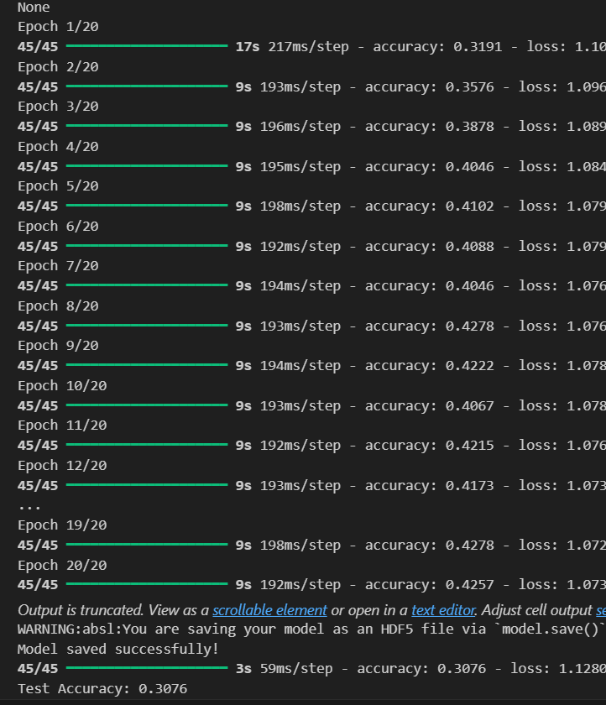

Step 4: Evaluation

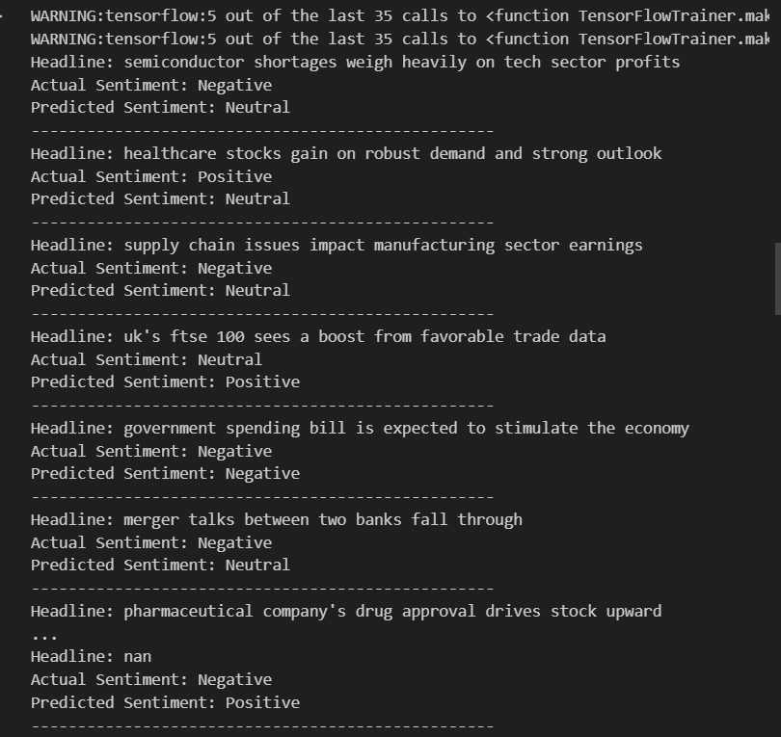

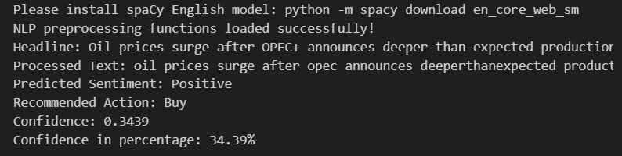

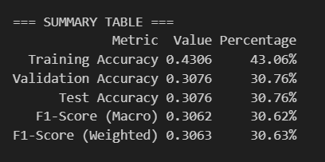

Step 5: Interpretation
The results indicate that the model’s performance is quite poor and suggests significant underfitting. The training accuracy of 42.99% shows that the model struggles to capture meaningful patterns even in the training data. Both validation and test accuracies are around 31.25%, which is close to random guessing for a three-class sentiment classification problem, implying that the model fails to generalize to unseen data. The F1-scores (both macro and weighted) are around 31%, confirming that performance is uniformly weak across all sentiment classes and that the dataset is likely balanced.
This underperformance could stem from several factors. The model may not have enough training data since half of the dataset was allocated to testing, leaving limited samples for learning. The LSTM architecture used is relatively simple, consisting of a single LSTM layer with 128 units and dropout, which may not be sufficient to capture complex patterns in text. Moreover, the model was trained for only 10 epochs, possibly too few for convergence. Other contributing issues could include the use of randomly initialized embeddings instead of pre-trained word vectors and minimal text preprocessing.
To improve performance, it would be beneficial to allocate a larger portion of data for training (e.g., 80% for training, 10% for validation, and 10% for testing), increase the number of training epochs, and enhance the network architecture with additional LSTM or dense layers. Using pre-trained embeddings such as GloVe or Word2Vec could significantly improve the model’s ability to understand language context. Additionally, applying thorough text preprocessing (like removing punctuation, converting to lowercase, and handling stopwords) and checking for class imbalance would further refine the model’s effectiveness.

7. CONCLUSION AND FUTURE SCOPE
This project successfully demonstrates the application of Deep Learning (LSTM) and NLP in analyzing and classifying sentiment from financial news data. The pipeline—from preprocessing to model training—shows that even a moderately sized dataset can yield strong predictive performance using an optimized LSTM model.

Key Takeaways
- LSTM networks are well-suited for sequential text data such as financial headlines.
- Word embeddings enable the model to learn semantic meaning beyond raw token frequency.
- Keras Tokenizer provides a simple yet efficient approach for handling text in deep learning workflows.

Future Enhancements
- Hyperparameter Optimization: Tune embedding dimensions, LSTM units, and dropout rates for improved generalization.
- Pre-trained Embeddings: Integrate GloVe or FastText vectors to enhance word understanding.
- Hybrid Models: Combine LSTM with CNN layers for feature extraction and contextual representation.
- Time-Series Correlation: Align news sentiment with market price data for predictive analysis.
- Web App Deployment: Build an interactive dashboard to predict sentiment from live financial headlines.

8. REFERENCES
- Project.ipynb — Jupyter Notebook prepared for this mini project.
- Dataset: financial_news_events.csv (provided).
- Chollet, F. (2018). Deep Learning with Python. Manning Publications.
- Jurafsky & Martin (2023). Speech and Language Processing, 3rd Edition.
- Loughran & McDonald (2011). When Is a Liability Not a Liability? Textual Analysis, Dictionaries, and 10-Ks. Journal of Finance.
- Hochreiter, S. & Schmidhuber, J. (1997). Long Short-Term Memory. Neural Computation.
- Mikolov, T. et al. (2013). Efficient Estimation of Word Representations in Vector Space (Word2Vec).
- Kingma, D. & Ba, J. (2015). Adam: A Method for Stochastic Optimization. ICLR.

